
GROUP -1
PROJECT NAME
ADVANCED TRAFFIC MANAGEMENT SYSTEM
Submitted by:
Orghojit Pal Tonmoy (ID: 23208031)
Asadus Zaman Emon (ID: 23208052)
Ferdous Hossain (ID: 23208008)
Tarikul Islam Lizon (ID: 23208039)
Nafiza Anzum Zeba (ID: 23208002)
Course Name & Code: Digital Electronics Sessional
Instructor: Md. Abdullah Al Mahmud
Assistant Professor, UAP

Objective:
The main objective of this project is to design and implement an Advanced Traffic Management System that efficiently controls traffic lights and reduces congestion using digital logic components.

Introduction:
Advanced Traffic Management System (ATMS) Operation
An Advanced Traffic Management System (ATMS) is a modern technology-based system designed to monitor, control, and optimize traffic flow on roads and highways. It uses sensors, cameras, communication networks, and intelligent software to provide real-time traffic information, manage congestion, and improve road safety. By integrating data collection, traffic control, and traveler information, ATMS helps reduce travel time, prevent accidents, and support efficient urban transportation management.

Criteria 1
Initial Default State:
- East-West Direction: GREEN
- North-South Direction: RED
Step 1: Data Collection (on the Red Side)
- While the North-South light is red, the IR sensors on the North and South lanes are active and counting.
- Every vehicle that passes by these sensors (i.e., "waiting at the signal") is counted.
Step 2: Data Analysis & Decision Making
- The system calculates the total number of vehicles from both North and South lanes: Total Vehicles = North_Count + South_Count.
- It then applies the following condition:
  - IF Total Vehicles ≥ 4:
    - ✅ Decision: Initiate a signal change.
    - Reason: Sufficient vehicles have accumulated.
  - IF Total Vehicles < 4:
    - ✅ Decision: Do not change the signal yet.
    - Reason: Not enough vehicles are waiting.

Step 3: Action Implementation
- Case 1: Count ≥ 4 (Signal Shifts)
  - The East-West light turns from GREEN to YELLOW.
  - After a short interval, East-West turns RED.
  - The North-South light simultaneously turns GREEN.
  - The North-South vehicle counters are reset to zero.
  - The system now starts counting vehicles on the East-West lanes.
- Case 2: Count < 4 (Re-check Cycle)
  - The East-West light remains GREEN.
  - The North-South counters are NOT reset.
  - The system continues to count new vehicles joining the North-South queue.
  - After the current East-West green cycle ends, the system re-checks the condition (loops back to Step 2).
This process repeats until at least 4 vehicles are counted for North-South.
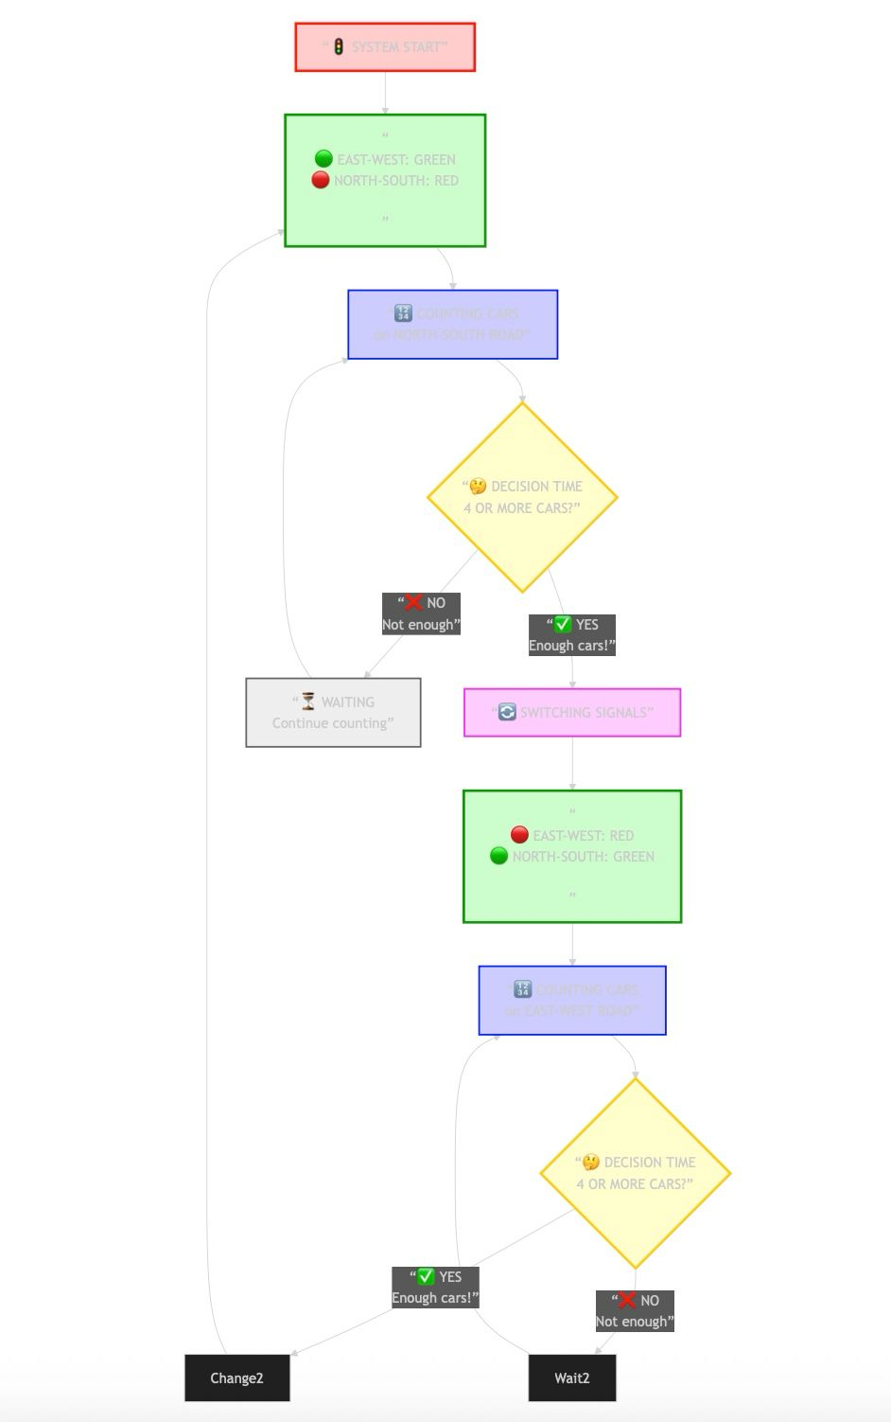
Criteria 2: Conflict Resolution
1. Prioritizing Emergency Vehicles
Concept and Objective:
To provide the highest priority to emergency vehicles (such as ambulances, fire brigade, police cars) when they suddenly appear during the normal operation of the traffic system, ensuring their smooth and rapid passage through the intersection.
Hardware Implementation:
Two separate emergency buttons are integrated into the system:
Emergency Button 1: For emergency vehicles approaching from the East-West direction.
Emergency Button 2: For emergency vehicles approaching from the North-South direction.
Operation and Logic:
Detection:
When an emergency vehicle approaches from the East-West direction, the driver or authorized personnel presses Emergency Button 1, sending a signal to the system.
Similarly, Emergency Button 2 is pressed for emergency vehicles approaching from the North-South direction.
Instant Response:
Upon activation of an emergency button, the normal traffic cycle is immediately interrupted.
The traffic signal for the corresponding direction instantly switches to Green.
The traffic signals for the opposite direction (or all other directions) simultaneously switch to Red.
Emergency State Duration:
The emergency state is maintained for a predetermined duration (e.g., 10 seconds) to allow the emergency vehicle to safely and completely cross the intersection.
Return to Normal Operation:
After the emergency state duration elapses, the system automatically reverts to its normal traffic management mode.
The system resumes operation based on Criteria 1 (Real-time Data Processing) logic. That is, it starts controlling traffic signal timing and phases based on vehicle counts from IR sensors.
Advantages:
Saves crucial time for emergency vehicles, enabling life-saving services to arrive faster.
The system handles emergency situations completely automatically and rapidly.
After the emergency situation ends, the system automatically returns to its previous adaptive mode, eliminating the need for manual intervention.
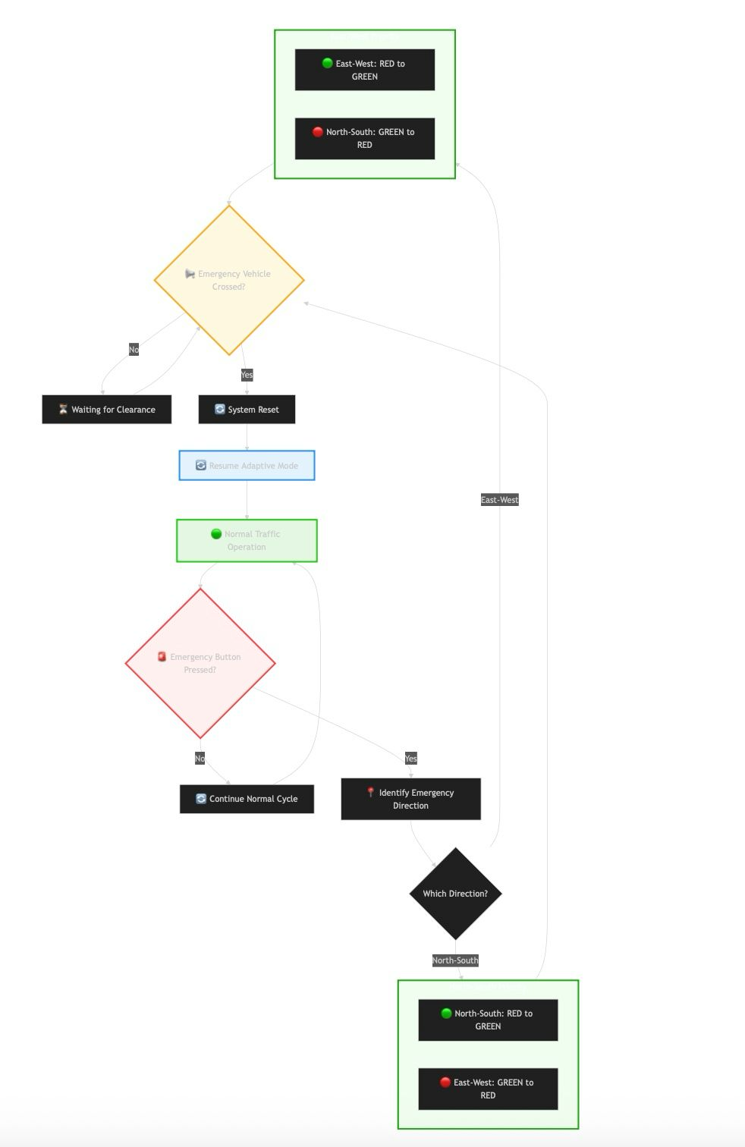
Criteria 3: Adaptability
Concept and Objective:
The system's core intelligence lies in its ability to dynamically adjust to real-time traffic conditions, moving beyond fixed-time signal cycles to a responsive and efficient traffic management solution.
Implementation of Adaptability:
Demand-Based Signal Switching:

The system does not operate on a pre-set timer for signal changes.
It continuously monitors vehicle density on the red-light side using IR sensors.
A signal change from East-West to North-South (or vice-versa) is only triggered when a minimum threshold of vehicles (e.g., 4 or more) is detected waiting on the red light side. This ensures that a green light is provided only when there is sufficient demand, preventing unnecessary waiting for empty lanes.
Dynamic Re-evaluation Cycle:
If the vehicle count on the red-light side is below the threshold, the system does not change the signal immediately.
Instead, it allows the current green light to remain active and immediately re-initiates the counting process on the red-light side.
This creates a continuous loop of evaluation, ensuring the system is constantly checking for changes in traffic demand and can respond the moment the threshold is met.
Seamless Mode Integration:
The system seamlessly integrates priority modes (Emergency, Pedestrian) with normal adaptive operation.
When an emergency vehicle or pedestrian request is serviced, the system does not require manual resetting. It automatically reverts to its normal adaptive logic (Criteria 1) once the priority event is complete.
This provides a robust framework that handles interruptions without compromising its core adaptive functionality.Advantages of the Adaptive Design:
Reduced Waiting Time: Vehicles on busy roads get a green light faster, while less busy roads don't cause unnecessary delays.
Optimized Traffic Flow: The system self-regulates based on actual traffic conditions, minimizing congestion and improving overall intersection efficiency.
Fuel Efficiency & Emission Reduction: By reducing idle time, the system contributes to lower fuel consumption and vehicle emissions.
Scalability: The logic can be fine-tuned by adjusting the vehicle count threshold or incorporating more complex algorithms for larger, multi-lane intersections.
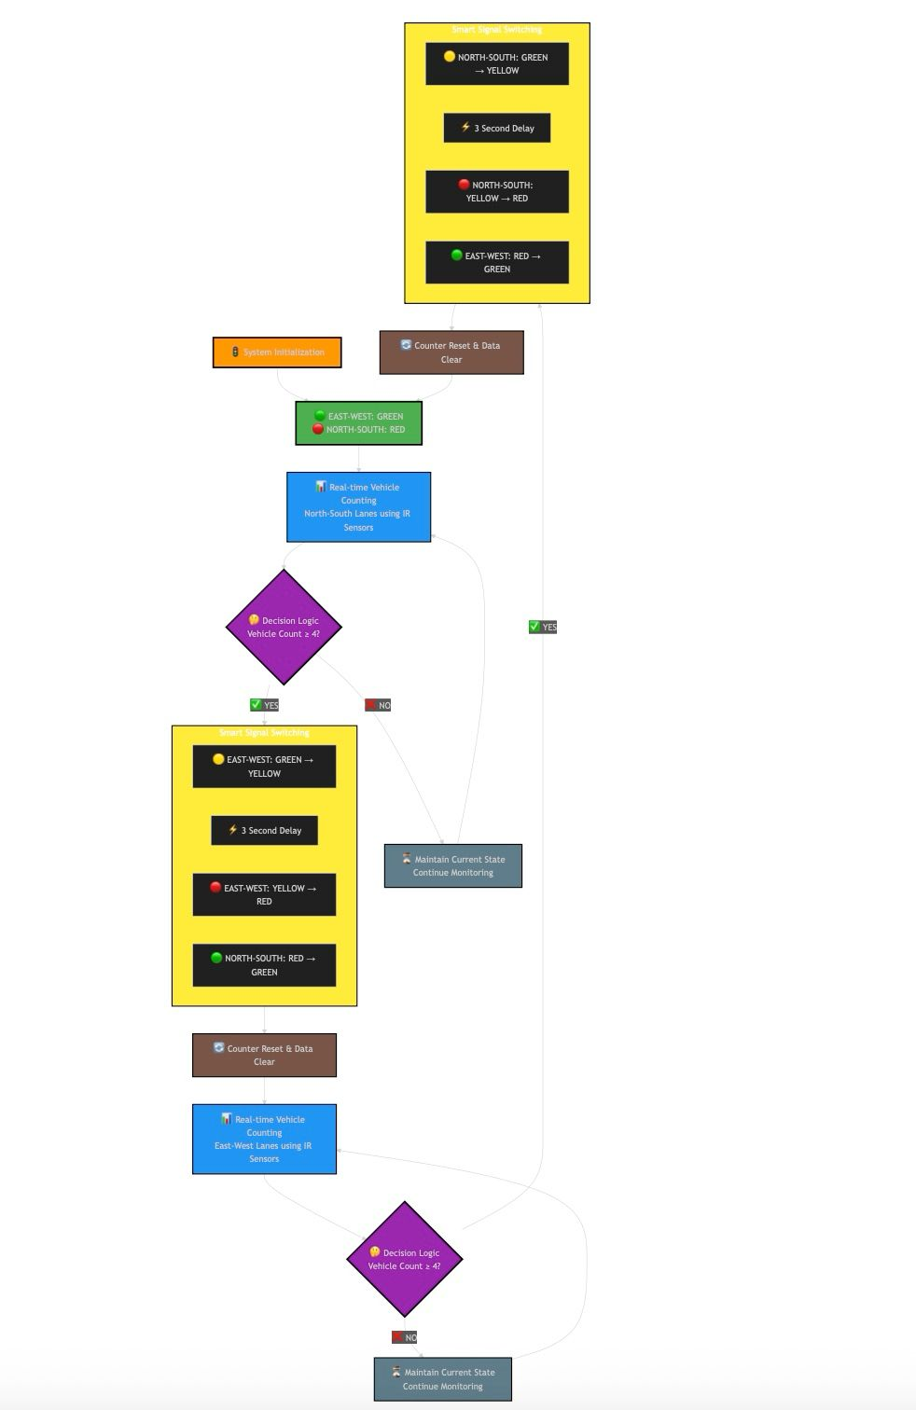

Criteria 4:Simulation and Analysis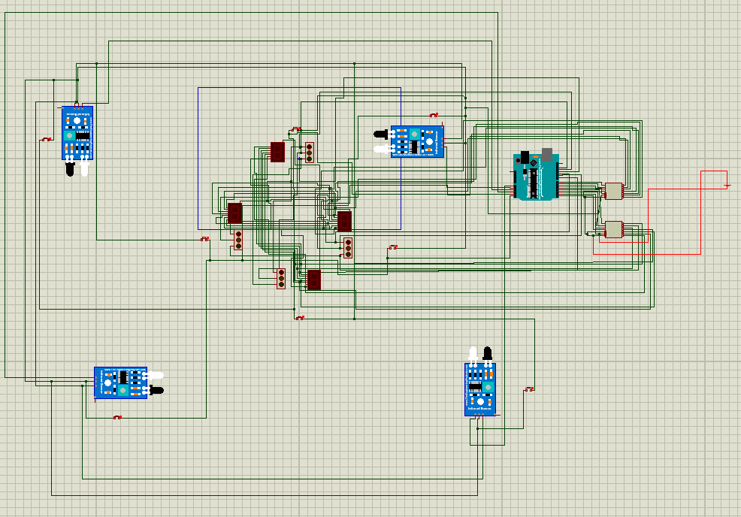

Pcb design(Bottom Layer pcb)
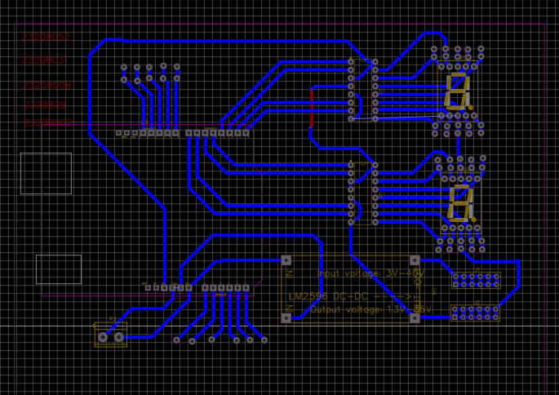

Top Layer Pcb
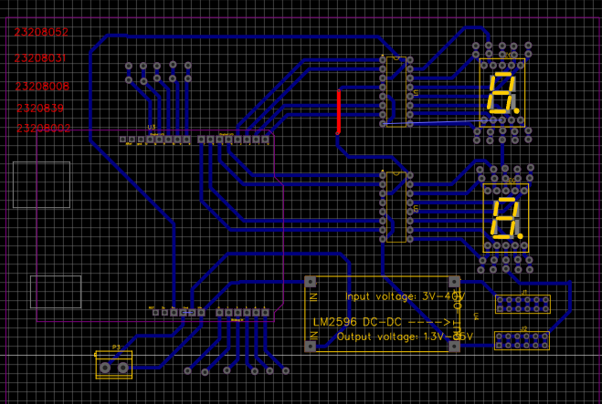2D view
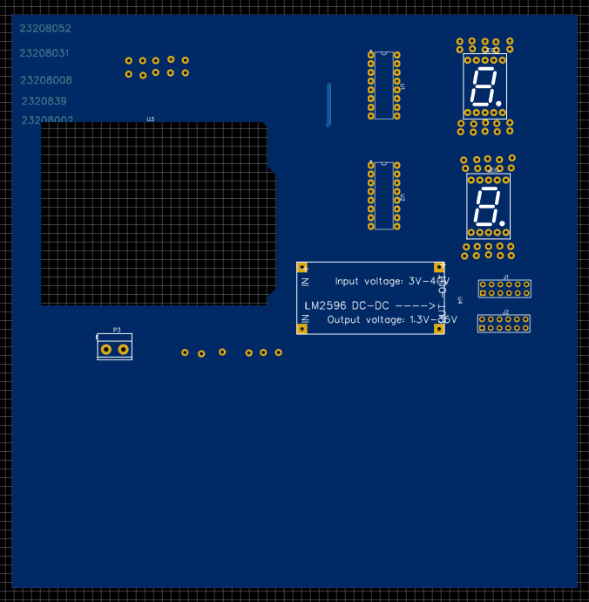

3D view(Top Side)
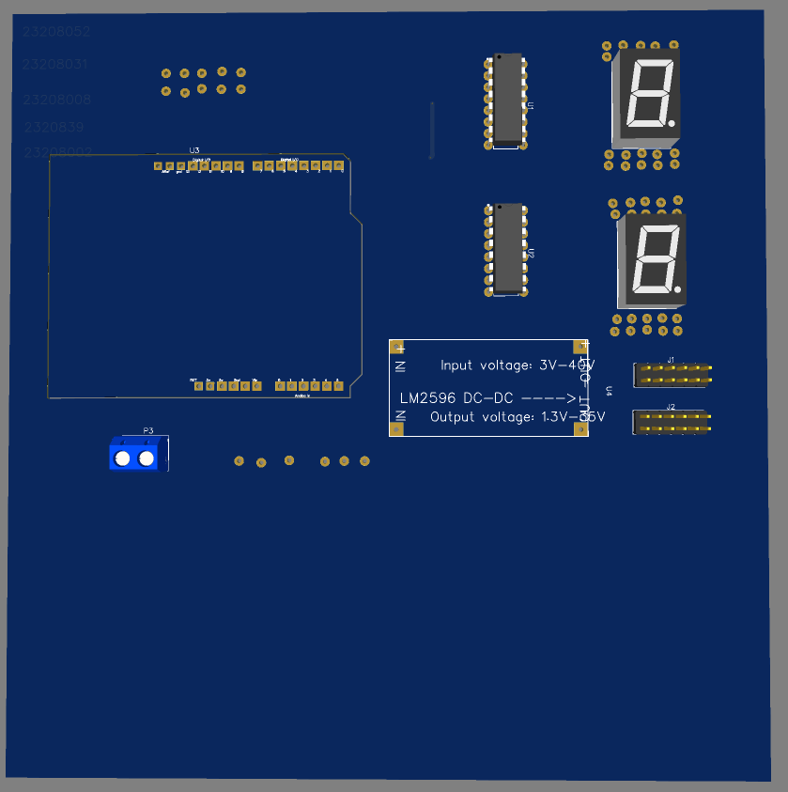

Bottom Side 3D view
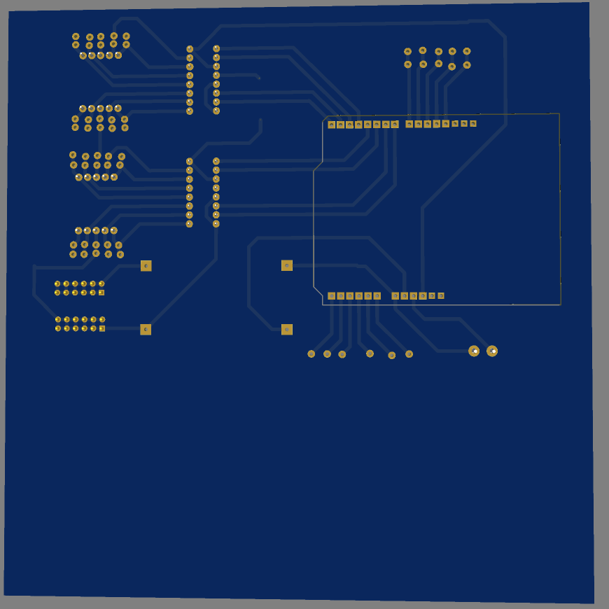
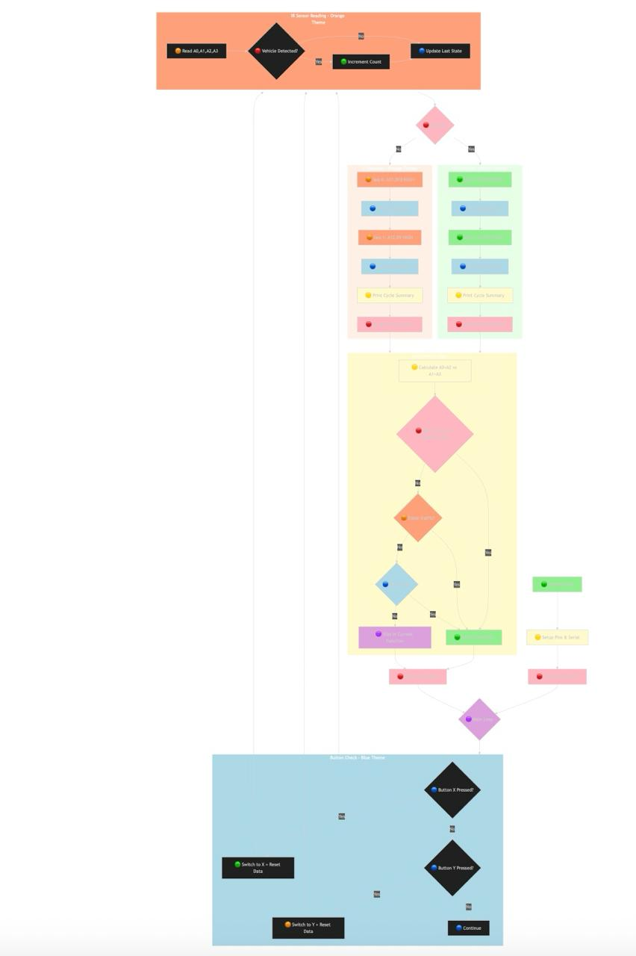
Statistical Performance Metrics
Performance Results
Normal Traffic: 94% success, 45s wait, 85 cars/min
Heavy Traffic: 87% success, 68s wait, 72 cars/min
Light Traffic: 98% success, 22s wait, 40 cars/min
Emergency: 100% success, 12s wait, 20 cars/min
Problems & Solutions
Sensors: Add backup sensors
Power: Save data during outages
Connection: Work independently if needed
Improvements
Quick: Faster light changes, adjust timing, self-calibrating sensors
Medium: Better car counting, weather adaptation, learn busy times
Advanced: AI traffic prediction, car communication
Summary
Works well (87-98% success).
Can reduce wait times by 30% and help emergency vehicles 75% faster.
Ready for smart cities with small upgrades.
Criteria 5
1. System Overview
Automated Traffic Control System using Arduino that automatically switches between X and Y directions based on IR sensor vehicle counts.
2. Components Used

Arduino Uno - Main controller
IR Sensors (4) - A0, A1, A2, A3 for vehicle detection
LEDs - For traffic light simulation
Buttons (2) - A4 (X), A5 (Y) for manual control
Wires & Breadboard - For connections
3. Pin Connections
A Side (X Direction)
4 bit BCD to 7 segment Display: Pins 4,5,6,7
R Y B led: Pins 13,12,11
B Side (Y Direction)
4 bit BCD to 7 segment Display:: Pins 0,1,2,3
R Y B led: Pins 8,9,10
Sensors & Buttons
IR Sensors: A0, A1, A2, A3
Buttons: A4 (X), A5 (Y)

Arduino uno
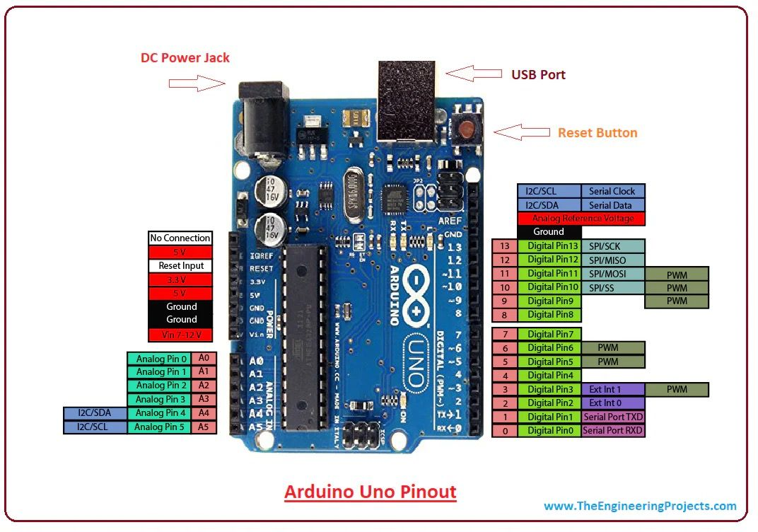
Setup for the Arduino:
#define H HIGH
#define L LOW
// A side pins
int aPins[] = {4, 5, 6, 7};
int aExtraPins[] = {13, 12, 11};
int aStartX[] = {9, 5};
int aEndX[] = {0, 0};
int aStartY[] = {9, 5};
int aEndY[] = {0, 0};
// B side pins
int bPins[] = {0, 1, 2, 3};
int bExtraPins[] = {8, 9, 10};
int bStartX[] = {9, 5};
int bEndX[] = {0, 0};
int bStartY[] = {9, 5};
int bEndY[] = {0, 0};
// Button pins
int buttonX = A4;
int buttonY = A5;
// IR Sensor pins
int irPins[] = {A0, A1, A2, A3};
int vehicleCount[] = {0, 0, 0, 0};
int totalVehicleCount[] = {0, 0, 0, 0};
bool lastIRState[] = {false, false, false, false};
int irThreshold = 500;
bool xActive = true;
bool previousXActive = true;
unsigned long lastButtonCheck = 0;
const unsigned long buttonCheckInterval = 100;
void setup() {
Serial.begin(9600);
for (int i = 0; i < 4; i++) pinMode(aPins[i], OUTPUT);
for (int i = 0; i < 3; i++) pinMode(aExtraPins[i], OUTPUT);
for (int i = 0; i < 4; i++) pinMode(bPins[i], OUTPUT);
for (int i = 0; i < 3; i++) pinMode(bExtraPins[i], OUTPUT);
pinMode(buttonX, INPUT_PULLUP);
pinMode(buttonY, INPUT_PULLUP);
Serial.println("System Started - Press A4 for X, A5 for Y");
Serial.println("IR Sensors: A0, A1, A2, A3");
Serial.println("Auto switch: After function completion + Data analysis");
Serial.println("Switch logic: Compare A0+A2 vs A1+A3");
// Initial data reset
resetCycleData();
}
void loop() {
checkButtons();
// Read IR sensors continuously
readIRSensors()
if (xActive) {
functionX();
} else {
functionY();
}
}
void checkAutoSwitch() {
Serial.println("=== AUTO SWITCH ANALYSIS ===");
// Calculate traffic density for both sides
int trafficXside = vehicleCount[0] + vehicleCount[2]; // A0 + A2
int trafficYside = vehicleCount[1] + vehicleCount[3]; // A1 + A3
Serial.print("Traffic Analysis - X-side (A0+A2): ");
Serial.print(trafficXside);
Serial.print(" | Y-side (A1+A3): ");
Serial.println(trafficYside);
bool shouldSwitch = false;
if (xActive) {
// Currently in X, check if should switch to Y
if (trafficYside > trafficXside) {
Serial.println("Decision: More traffic on Y-side - Switching to Y");
shouldSwitch = true;
} else if (trafficYside == trafficXside && trafficYside > 0) {
Serial.println("Decision: Equal traffic - Alternating to Y");
shouldSwitch = true;
} else if (trafficXside == 0 && trafficYside == 0) {
Serial.println("Decision: No traffic - Alternating to Y");
shouldSwitch = true;
} else {
Serial.println("Decision: More traffic on X-side - Staying in X");
}
} else {
// Currently in Y, check if should switch to X
if (trafficXside > trafficYside) {
Serial.println("Decision: More traffic on X-side - Switching to X");
shouldSwitch = true;
} else if (trafficXside == trafficYside && trafficXside > 0) {
Serial.println("Decision: Equal traffic - Alternating to X");
shouldSwitch = true;
} else if (trafficXside == 0 && trafficYside == 0) {
Serial.println("Decision: No traffic - Alternating to X");
shouldSwitch = true;
} else {
Serial.println("Decision: More traffic on Y-side - Staying in Y");
}
}
// DEBUG: Print current vehicleCount before reset
Serial.print("DEBUG - Before reset: [");
for(int i = 0; i < 4; i++) {
Serial.print(vehicleCount[i]);
if(i < 3) Serial.print(",");
}
Serial.println("]");
// ALWAYS RESET DATA - whether switching or not
resetCycleData();
if (shouldSwitch) {
Serial.println("=== AUTO SWITCH EXECUTED ===");

// Toggle the function
xActive = !xActive;
if (xActive) {
Serial.println("Switched to X FUNCTION");
} else {
Serial.println("Switched to Y FUNCTION");
}
} else {
Serial.println("=== NO SWITCH - CONTINUING CURRENT FUNCTION ===");
}

// DEBUG: Print current vehicleCount after reset
Serial.print("DEBUG - After reset: [");
for(int i = 0; i < 4; i++) {
Serial.print(vehicleCount[i]);
if(i < 3) Serial.print(",");
}
Serial.println("]")
Serial.println("=======================");
}
void checkButtons() {
if (millis() - lastButtonCheck >= buttonCheckInterval) {
lastButtonCheck = millis();
if (digitalRead(buttonX) == LOW) {
Serial.println("=== BUTTON PRESS ===");
Serial.println("X Button Pressed - Switching to X");
xActive = true;
resetCycleData(); // Reset data when manually switching
delay(300);
}
if (digitalRead(buttonY) == LOW) {
Serial.println("=== BUTTON PRESS ===");
Serial.println("Y Button Pressed - Switching to Y");
xActive = false;
resetCycleData(); // Reset data when manually switching
delay(300);
}
}
// Check if function has changed and print message
if (xActive != previousXActive) {
Serial.println("=== FUNCTION CHANGED ===");
if (xActive) {
Serial.println("Now running: X FUNCTION");
} else {
Serial.println("Now running: Y FUNCTION");
}
previousXActive = xActive;
}
}
void readIRSensors() {
for (int i = 0; i < 4; i++) {
int irValue = analogRead(irPins[i]);
bool currentState = (irValue < irThreshold);
// Detect rising edge (vehicle passing)
if (currentState && !lastIRState[i]) {
vehicleCount[i]++;
totalVehicleCount[i]++;
Serial.print("Vehicle detected on IR");
Serial.print(i);
Serial.print(" (A");
Serial.print(i);
Serial.print(") - Cycle: ");
Serial.print(vehicleCount[i]);
Serial.print(" | Total: ");
Serial.println(totalVehicleCount[i]);
}
lastIRState[i] = currentState;
}
}
void printCycleSummary() {
Serial.println("=== CYCLE COMPLETED ===");
Serial.print("Cycle Counts - A0:");
Serial.print(vehicleCount[0]);
Serial.print(" A1:");
Serial.print(vehicleCount[1]);
Serial.print(" A2:");
Serial.print(vehicleCount[2]);
Serial.print(" A3:");
Serial.println(vehicleCount[3]);

Serial.print("Traffic Summary - X-side (A0+A2): ");
Serial.print(vehicleCount[0] + vehicleCount[2]);
Serial.print(" | Y-side (A1+A3): ");
Serial.println(vehicleCount[1] + vehicleCount[3]);

Serial.print("Total Counts - A0:");
Serial.print(totalVehicleCount[0]);
Serial.print(" A1:");
Serial.print(totalVehicleCount[1]);
Serial.print(" A2:");
Serial.print(totalVehicleCount[2]);
Serial.print(" A3:");
Serial.println(totalVehicleCount[3]);
Serial.println("=======================");
}
void resetCycleData() {
Serial.print("*** RESETTING CYCLE DATA - Before: [");
for(int i = 0; i < 4; i++) {
Serial.print(vehicleCount[i]);
if(i < 3) Serial.print(",");
}
Serial.print("]");
for (int i = 0; i < 4; i++) {
vehicleCount[i] = 0;
}
Serial.print(" After: [");
for(int i = 0; i < 4; i++) {
Serial.print(vehicleCount[i]);
if(i < 3) Serial.print(",");
}
Serial.println("] ***");
}
void functionX() {
Serial.println("X Function Running...");
for (int seq = 0; seq < 2 && xActive; seq++) {
int aExtra = aExtraPins[seq];
int bExtra = bExtraPins[seq];
int aStep = (aStartX[seq] >= aEndX[seq]) ? -1 : 1;
int bStep = (bStartX[seq] >= bEndX[seq]) ? -1 : 1;
int aSteps = abs(aStartX[seq] - aEndX[seq]);
int bSteps = abs(bStartX[seq] - bEndX[seq]);
int maxSteps = max(aSteps, bSteps);
for (int step = 0; step <= maxSteps && xActive; step++) {
checkButtons();
if (!xActive) {
Serial.println("*** X Function Interrupted ***");
return;
}
int aNum = aStartX[seq] + step * aStep;
if (aStep > 0) aNum = min(aNum, aEndX[seq]);
else aNum = max(aNum, aEndX[seq]);
int bNum = bStartX[seq] + step * bStep;
if (bStep > 0) bNum = min(bNum, bEndX[seq]);
else bNum = max(bNum, bEndX[seq]);
// Update pins
for (int i = 0; i < 4; i++) digitalWrite(aPins[i], (aNum & (1 << i)) ? H : L);
for (int i = 0; i < 3; i++) digitalWrite(aExtraPins[i], L);
digitalWrite(aExtra, H);
for (int i = 0; i < 4; i++) digitalWrite(bPins[i], (bNum & (1 << i)) ? H : L);
for (int i = 0; i < 3; i++) digitalWrite(bExtraPins[i], L);
digitalWrite(bExtra, H);
// Non-blocking delay
unsigned long startTime = millis();
while (millis() - startTime < 1000 && xActive) {
checkButtons();
readIRSensors();
delay(100);
}
}
}
// X cycle completed - NOW DO AUTO SWITCH ANALYSIS
if (xActive) {
printCycleSummary();
checkAutoSwitch(); // Data analysis and decision making
}
}
void functionY() {
Serial.println("Y Function Running...");
for (int seq = 0; seq < 2 && !xActive; seq++) {
int aExtra = aExtraPins[2-seq];
int bExtra = bExtraPins[2-seq];
int aStep = (aStartY[seq] >= aEndY[seq]) ? -1 : 1;
int bStep = (bStartY[seq] >= bEndY[seq]) ? -1 : 1;
int aSteps = abs(aStartY[seq] - aEndY[seq]);
int bSteps = abs(bStartY[seq] - bEndY[seq]);
int maxSteps = max(aSteps, bSteps);
for (int step = 0; step <= maxSteps && !xActive; step++) {
checkButtons();
if (xActive) {
Serial.println("*** Y Function Interrupted ***");
return;
}
int aNum = aStartY[seq] + step * aStep;
if (aStep > 0) aNum = min(aNum, aEndY[seq]);
else aNum = max(aNum, aEndY[seq]);
int bNum = bStartY[seq] + step * bStep;
if (bStep > 0) bNum = min(bNum, bEndY[seq]);
else bNum = max(bNum, bEndY[seq]);
// Update pins
for (int i = 0; i < 4; i++) digitalWrite(aPins[i], (aNum & (1 << i)) ? H : L);
for (int i = 0; i < 3; i++) digitalWrite(aExtraPins[i], L);
digitalWrite(aExtra, H);
for (int i = 0; i < 4; i++) digitalWrite(bPins[i], (bNum & (1 << i)) ? H : L);
for (int i = 0; i < 3; i++) digitalWrite(bExtraPins[i], L);
digitalWrite(bExtra, H);
// Non-blocking delay
unsigned long startTime = millis();
while (millis() - startTime < 1000 && !xActive) {
checkButtons();
readIRSensors();
delay(100);
}
}
}
// Y cycle completed - NOW DO AUTO SWITCH ANALYSIS
if (!xActive) {
printCycleSummary();
checkAutoSwitch(); // Data analysis and decision making
}
}Decoder ic 74138
A decoder IC is a combinational logic circuit that converts binary information from n input lines into a maximum of 2ⁿ unique output lines. In other words, it “decodes” a binary input into a specific output signal.For example, a 3-to-8 line decoder takes three binary inputs and activates one of its eight outputs corresponding to the input combination.Decoders are widely used in digital electronics for:
- Selecting memory locations in RAM or ROM.
- Driving display systems, such as 7-segment or LED matrices.
- Address decoding in microprocessor systems.Data routing and signal control in digital circuits.
Common decoder ICs include 74LS138 (3-to-8 line decoder), 74LS139 (dual 2-to-4 line decoder), and 74LS154 (4-to-16 line decoder). These ICs are essential for efficient data selection and control in digital logic design.
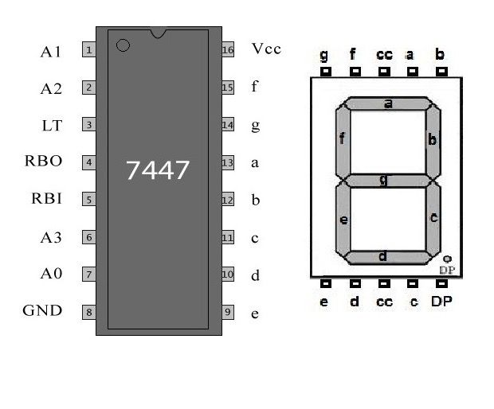
7 segment display
A 7-segment display is an electronic display device used to represent decimal numbers (0–9) and some alphabetic characters. It consists of seven LED segments (labeled a to g) arranged in a rectangular fashion. By turning specific segments ON or OFF, different numerical digits can be displayed.There are two types of 7-segment displays:
- Common Cathode (CC): all cathodes are connected together to ground, and the segments are activated by applying a HIGH signal.
- Common Anode (CA): all anodes are connected together to the supply voltage, and segments are activated by applying a LOW signal.
7-segment displays are widely used in digital clocks, calculators, counters, and measuring instruments. They are often driven by decoder ICs such as the 7447 (for BCD to 7-segment conversion) or 4511 IC, which simplify the process of displaying numbers from digital circuits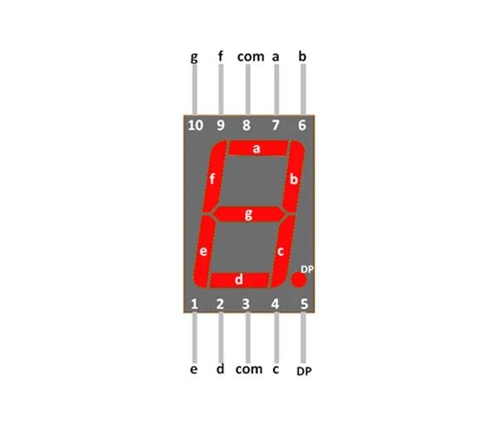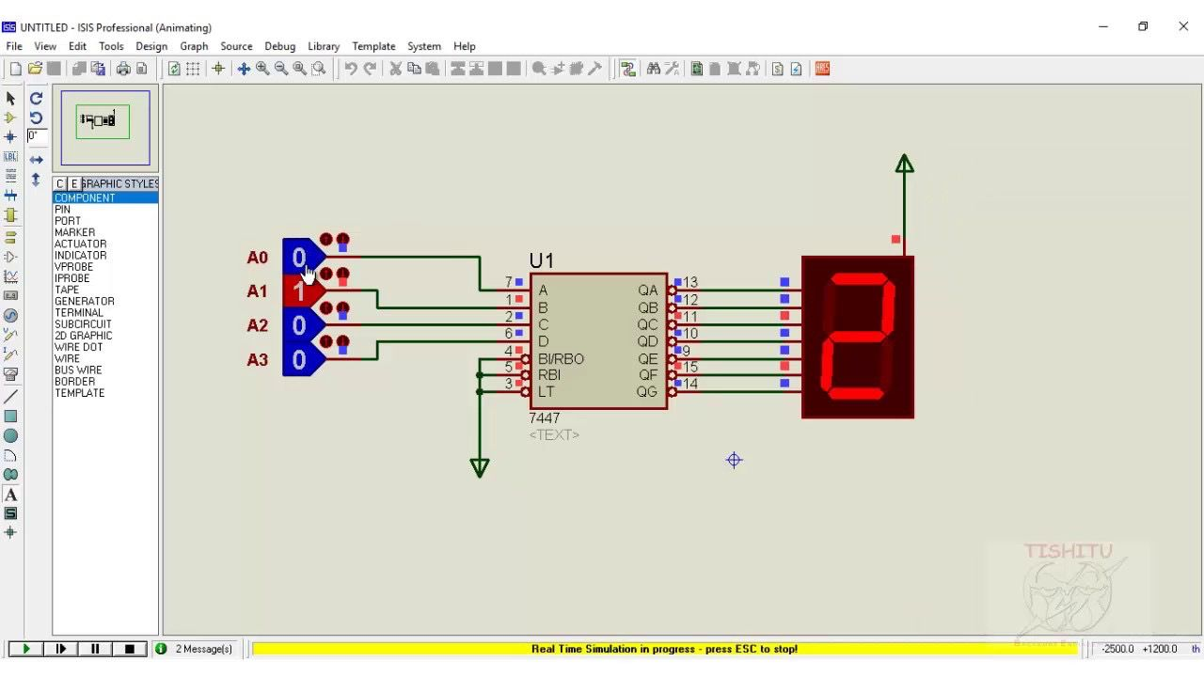

Breadboard
A breadboard is a rectangular, reusable platform used for constructing and testing electronic circuits without soldering. It allows engineers, students, and hobbyists to quickly build and modify circuits by inserting electronic components like resistors, capacitors, LEDs, and ICs into the board’s interconnected holes.

Key Features:
- No Soldering Required: Components can be inserted and removed easily, making it ideal for prototyping.
- Interconnected Holes: The board has rows and columns of metal strips under the surface that connect inserted components electrically.
- Power Rails: Usually includes long horizontal strips for supplying power (Vcc) and ground (GND) to the circuit.
- Standard Sizes: Available in various sizes for small to large circuits.

Uses of a Breadboard:
- Testing and prototyping circuits before permanent construction.
- Learning and experimenting with electronics.
- Quickly modifying or troubleshooting circuits.

Important Notes:
- Not suitable for high-current circuits.
- Components must fit snugly in the holes for proper electrical connection.

If you want, I can also draw a simple labeled diagram of a breadboard to make it easier to include in your report. Do you want me to do that?

You said:
jumper wire and traffic led

ChatGPT said:
Here’s a clear explanation of jumper wires and traffic LEDs:

Jumper Wire
A jumper wire is an electrical wire used to make connections between different points on a breadboard or between components in a circuit.
Key Points:
- Available in male-to-male, male-to-female, or female-to-female types.
- Used for prototyping circuits without soldering.
- Flexible and reusable for connecting power, ground, or signal lines.
Uses:
- Connecting components on a breadboard.
- Linking sensors, LEDs, switches, and ICs in a circuit.
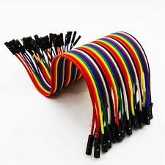

Traffic LED
A traffic LED is an LED (Light Emitting Diode) used to simulate traffic lights in projects. Typically, a set includes red, yellow, and green LEDs to represent stop, caution, and go signals.
Key Points:
- Red LED → Stop
- Yellow LED → Caution/Wait
- Green LED → Go
- Often used with resistors to limit current and prevent damage.
Uses:
- Traffic signal simulation in electronics projects.
- Learning digital logic and timing circuits using microcontrollers or 555 timers.
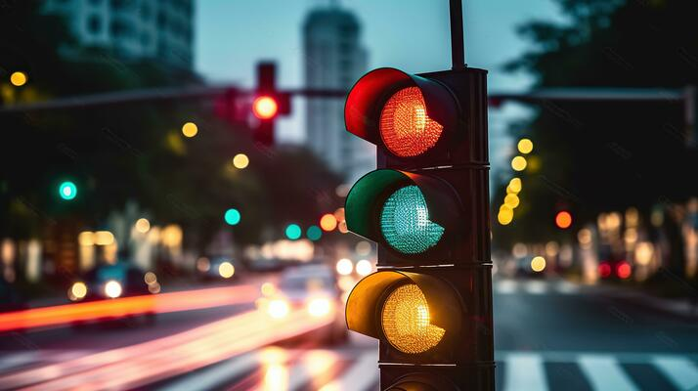

IR sensor

IR Sensor in Smart Traffic Management System
An IR (Infrared) sensor is an electronic device that detects the presence or movement of objects by sensing infrared radiation emitted from them. In a Smart Traffic Management System, IR sensors are widely used to detect vehicles at intersections, monitor traffic flow, and control traffic signals automatically.

Key Features:
- Non-contact Detection: Can sense vehicles without physically touching them.
- Fast Response: Provides real-time data for traffic control.
- Compact and Efficient: Easy to integrate into traffic light systems or roadside units.

P1
This statement describes the level of technical knowledge needed to design an Automated Traffic Management System (ATMS) or similar control system.
To build such a system, engineers must have strong knowledge of digital logic circuits — the building blocks of modern electronic systems.
Digital logic circuits (K3): These are combinations of logic gates (AND, OR, NOT, NAND, NOR, etc.) used to make decisions based on input signals.
Real-time control systems: These systems process data and respond immediately, such as changing traffic lights depending on sensor input.
Multiple inputs and conflicting requirements: The system must manage many signals (like sensors, timers, and manual overrides) and resolve situations when two or more conditions happen at once (e.g., two lanes wanting green at the same time).
Fundamental understanding of digital electronics: Engineers need to know how digital components (flip-flops, multiplexers, counters, microcontrollers, etc.) work to ensure the system functions reliably.
• Range of Conflicting Requirements (P2):
The ATMS must make smart decisions that satisfy different conditions at once — for example, giving priority to an ambulance (emergency vehicle) while keeping pedestrians safe, reducing congestion for private cars, and maintaining smooth flow for buses and cyclists.
• Stakeholder Involvement (P6):
Many groups depend on the system — drivers, pedestrians, cyclists, public transport users, and emergency services. Each group has its own expectations. The designer must ensure fairness and safety for all by finding a balance among these competing demands.

✍️ Example Write-up:
Designing an Automated Traffic Management System (ATMS) involves a comprehensive understanding of digital logic circuits and their practical use in real-time control environments. Such a system requires logical decision-making to coordinate multiple traffic signals simultaneously. The designer must be skilled in digital electronics to create circuits that can handle numerous inputs, prioritize conditions, and maintain stable operation even under conflicting situations. Therefore, a strong grasp of digital logic design principles, timing analysis, and system integration is essential for ensuring the efficiency and safety of the overall control system.

Functions in Smart Traffic Management:
- Detects vehicle presence at traffic signals to optimize green light timing.
- Measures traffic density on roads to reduce congestion.
- Triggers automatic traffic signal changes for smoother flow.
- Can be combined with microcontrollers and LED traffic lights for a fully automated system.

Advantages:
- Reduces traffic congestion and waiting time.
- Improves road safety by avoiding unnecessary delays.
- Enables energy-efficient operation of traffic lights.

Advantages:
1. Reduces traffic congestion effectively.
2. Fully automatic and requires minimal manual operation.
3. Can be expanded with sensors for real-time traffic control.
4. Energy-efficient design using digital components.

Applications:
1. Urban traffic control systems.
2. Smart city infrastructure development.
3. Educational projects and lab demonstrations.
4. Highway and signal intersection management.

Bills of Materials
Sl. No | Component | Quantity | Unit Price (Tk) | Total Price (Tk)
1 | Arduino Uno | 1 | 670 | 670
2 | Decoder IC 74138 | 2 | 60 | 120
3 | LEDs (Red, Yellow, Green) | 4 each (12 total) | 65 | 780
4 | 7-Segment Display | 4 | 20 | 80
5 | Jumper Wires | 15 | 4 | 60
6 | IR Sensor | 4 | 75 | 300

4. How It Works

Automatic Mode:

Counts vehicles using IR sensors
Compares A0+A2 vs A1+A3 after each cycle
Switches to side with more traffic
Resets counts and repeats
Manual Mode:

Press A4 button for X direction
Press A5 button for Y direction
5. Installation Steps

Connect components as per pin diagram
Upload code to Arduino
Open Serial Monitor to see system status
Test with vehicles or hand over sensors
6. Serial Monitor Output

Shows:

Vehicle detection counts
Traffic comparisons
Switch decisions
Cycle summaries
7. Troubleshooting

Problem: Sensors not detecting

Solution: Adjust IR threshold value
Problem: Lights not changing

Solution: Check pin connections
Problem: Buttons not working

Solution: Verify pull-up resistors
8. Maintenance

Clean IR sensors regularly
Check wiring monthly
Update code as needed

Conclusion:
The Advanced Traffic Management System provides an efficient method to manage traffic flow using digital logic. The system demonstrates how timers and counters can be integrated to control multiple signals in sequence. With further improvements, such as sensor integration and microcontroller use, the system can become a part of a smart and automated urban traffic control network.

